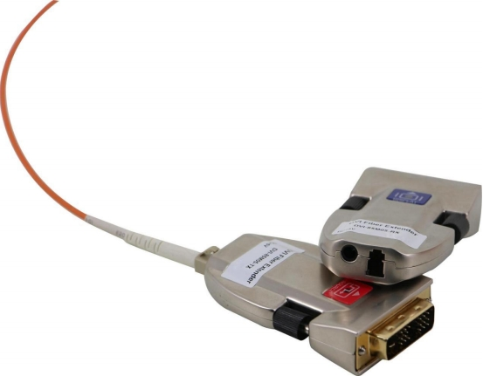

User Manual
HT401-DVI-MINI-T/R-A
2 KM 1 core LC fiber extender with EDID management

Version: V2018.001

1

Contents
- Production ................................................................................................................ 3
- Features .................................................................................................................... 3
- Specification ............................................................................................................. 3
- Packing ..................................................................................................................... 3
- Connection Diagram ................................................................................................ 4
- System installation requirements ........................................................................... 4
6.1 Hardware ..................................................................................................................... 5
6.2 Software ...................................................................................................................... 5
- 3 AC/DC Suggestions ...................................................................................................... 5
- Operation and instruction ....................................................................................... 4
- Commen issues and attentions .............................................................................. 5
8.1 Commen issues and maintenance .............................................................................. 5
- 2 Attention ......................................................................................................................6
- After-sales ................................................................................................................ 6
9.1 Warranty ...................................................................................................................... 6
- 2 Lmitation ..................................................................................................................... 6
- Version Information ............................................................................................... 6

2

1. Introduction
HT401-DVI-MINI-T/R-A is a 1 core LC connector DVI Fiber Optic Extender, with single model fiber cable can transmit to a distance of 2km, resolution can reach WUXGA(1920*1200@60Hz), the bandwidth is 10Gbps. No loses, compression, latency during the whole transmission. With optoelectronic multiplex technology, this equipment consists of two parts: Transmitter and receiver. Transmitter using the V-EDID technology, it can supports EDID learning and coding to reach the best display effect. With EDID leaning technology in the transmitter, it can adopt different resolution display systems, it help users to make the project neat, convenient and stable.
2. Features

Transmits the DVI signal to 2 km with 1 core single fiber cable. The max resolution can up to 4K30Hz
No loses, compression and latency during the transmission Supports EDID learning and coding
Support 7×24h working
Support DVI1.0 protocol and HDMI1.4

3. Specification
Type | HT401-DVI-MINI-T/R-A-4F | HT401-DVI-MINI-T/R-A-2F | HT401-DVI-MINI-T/R-A-1F
Description | DVI 4 cores SM 10km | DVI 2 cores SM 10km | DVI 1 core SM 2 km
Interface | LC
Distance | 10KM(Single model) | 10KM(Single model) | 2KM(Single model)
Resolution | 1080p60Hz | 1080p60Hz | 4K30Hz
EDID | Supports | Supports | Supports
Protocol | DVI1.0 | DVI1.0 | DVI1.0, HDMI1.4
Bandwidth | 2.5Gbps | 2.5Gbps | 10Gbps
Color Space | RGB444/ YUV444/ YUV422, supports x.v.Color extension and standard
Power Supply | 110---260V 50/60Hz AC Input， 5V 1A Output
Dimension | 15mm ×39mm×66mm（H/W/L）
weight | 190g(A pair)
Humidity | 10%-90%
Working | -10℃ - 50℃
Storage | -25℃ - 55℃
4. Packing
HT401-DVI-MINI-T/R-A(1 transmitter and 1 receiver) | 1 | Pair
DC 5V1A power adapter | 2 | Pcs

3

5. Connection diagram

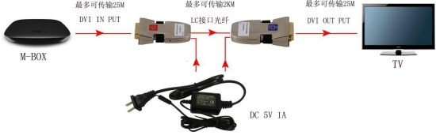
6. System installation requirements
6.1 Hardware
Devices need to have the DVI interface and support DVI resolution

6.2 Software
There is no special requests as long as the DVI image controller has been well installed.
6.3 AC/DC Suggestions
Transmitter has the power protection system, users can use other adapters which can provide 5V power supply, for the receiver should use the adapter which come together in the packing.
7. Operation and instruction
Note: Please follow the following steps, otherwise it may not working.
Step 1:
EDID learning/ Coding: Please power on the display first, then plug the transmitter to the display and power on with the 5V1A power adapter(Note: Need to get the transmitter connected with the display first, then power on the transmitter), then the LED indicator on the opposite side will light up in red, and the LED indicator on the up side will light up in blue and last for 8-10 seconds and off, it means the EDID has learned successfully; If the indicator after lighting up 8-10 second, and flicking for 3 times then off, it means the EDID learning was failed.
Note: If need to exchange the display, please remember to repeat the step 1
Step 2:
Plug the transmitter to DVI port of the input sources. Make sure to power the transmitter and the red LED indicator is lighting up.
Note: Please don’t use other power adapters to have the perfect performance.

4

Step 3:
Please power on the receiver with 5V adapter and see the red LED indicator is lighting up
Step 4:
Get the receiver well connected with DVI port on the display
Step 5:
Using the single model fiber cable well connect the receiver and transmitter
- tep 6:
- urn on or power on the sources
Step 7:
Last step, if users using the Windows system, only need to set up the best resolution which the display can support.
Note: If users using the IOS system, couldn’t see the original image after connection, users have to repeat Step 1 and step 2 to set up.

8. Common issues and attentions
8.1 Common issues and maintenance
(1) Only black on the display?

Make sure all the power supply is tight and stable. Meanwhile, make sure the red LED indicator light up.
Follow the Step 1 to make the EDID learning or coding successfully.
Make sure the extender connected with the DVI display tightly.
Make sure the receiver is connected with the display and the transmitter is well connected with the input source.
Check the power supply for the sources and display is working good.
Try to plug-out or plug-in the extender again, or disconnect the power supply for a few seconds and power on again.

(2) The image on the display is out of shape or noisy

➢
Check the resolution is suitable or not.

- Make sure the resolution is under 4K30Hz.
- Disconnect the power supply and power on again or the DVI cable and restart the extender
8.2 Attention
➢ Please well protect the power cord, fiber cable, in case of the cable damage cause the problem

Avoid any liquid, electronic or dusty staff get into the equipment.
Working temperature should between -10 ℃ -50 ℃ , and make sure the dry and cool
5

➢
place
Try not to plug-in/out the equipment when power on

9. After-Sales
9.1 Warranty Information
The Company warrants that the process and materials of the product are not defective under normal use and service for 3 (3) years following the date of purchase from the Company or its authorized distributors.
If the product does not work within the guaranteed warranty period, the company will choose and pay for the repair of the defective product or component, the delivery of the equivalent product or component to the user for replacement of the defective item, or refund the payment which users have made.
The replaced product will become the property of the Company.
The replacement product could be new or repaired.
Whichever is longer, any replacement or repaired of the product or component is for a period of ninety (90) days or the remaining period of the initial warranty. The Company shall not be responsible for any software, firmware, information, or memory data contained in, stored in, or integrated with the product repaired by the customer's return, whether or not during the warranty period.
9.2 Warranty limitations and exceptions
Except above limited warranty, if the product is damaged by over usage, incorrectly use, ignore, accident, unusual physical pressure or voltage, unauthorized modification, alteration or services rendered by someone other than the Company or its authorized agent, the company will not have to bear additional obligations. Except using the product properly in the proper application or normal usage

10. Version Information

Description of version（Document number：HT401-DVI-MINI-T/R-A）
Date | Version number | Description
Dec 2016 | V1.01.01 | First version

6

