4GE+ 2POTS + CATV+ Wi-Fi +1USB GPON ONT
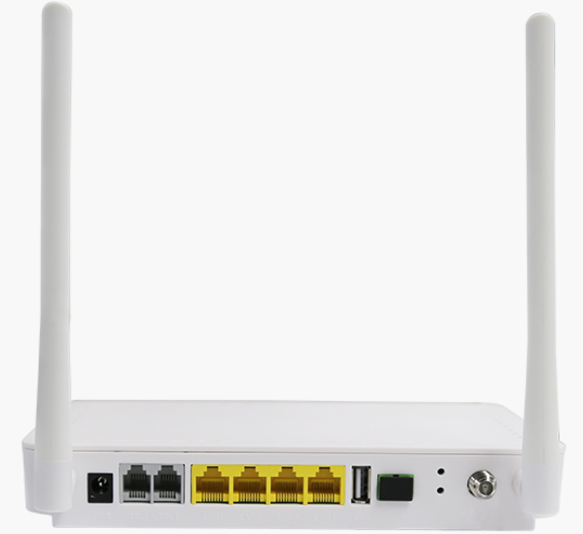
HT3442GVWUC(4GE+2POTS+RF+Wi-Fi+1USB) is fiber to the home multi service access GPON ONT. It’s based on the mature, stable, high cost performance GPON technology and has gigabit Ethernet switching, WDM and HFC technology. HT3442GVWUC has a higher bandwidth, higher reliability, easy management and good quality of service (QoS) guarantee with technical performance of equipment meet the ITU G. 984 requirements and have good compatibility with third party manufacturers OLT.

It adopts single fiber WDM technology with downlink wavelength 1490nm and 1550nm, uplink wavelength 1310nm. It only needs one-core fiber to transmit data service.

ONT HT3442GVWUC provides 1 PON port , 2 POTS port, 4 10/100/1000M Ethernet adaptive ports, one CATV RF output and one USB port, support double frequency Wi-Fi function.

PRODUCT FEATURES：
Full compatible with ITU-T G.984
Support twoPOTS
Support four GE auto-adapting Ethernet ports
Support 802.11a/b/g/n/acWi-Fi access, while support 2.4GHz and 5GHz
Support oneCATV output
Support OMCI and TR069 for remote management
Support Auto-negotiation andMDI/MDIX
Support the Ethernet interface rate, working mode andflows control configuration
Support loopback at UNI
Support packet filtering and illegal message attack protection
Support performance statistics of Ethernet link
Support VLAN tagged label processing, traffic classification and packet filtering, STP/RSTP etc.
Support DHCP Option60 reporting the location information of the Ethernet interface
Support PPPoE+ for accurate subscribers identification
Support H.248and SIP protocol
Support IGMP Snooping
Support AES-128
Support Dynamic Bandwidth Allocation (DBA)

Technical specifications
Item |  | Parameter
Interface | Uplink Interface | 1*GPON port, FSAN G.984.2 standard, Class B+  Downstream Data Rate：2.488Gbps  Upstream Data Rate：1.244Gbps  SC/PC single mode fiber  28dB Link loss and 20KM distance with 1:128
 | CATV Interface | 1 RF output  F-Type Connector
 | POTS Port | 2*RJ11 with 3REN  Max 1km distance  Balanced Ring, 50V RMS
 | Ethernet Interface | 4*10/100/1000M auto-negotiation  Full/half duplex mode  RJ45 connector  Auto MDI/MDI-X  100m distance
 | USB interface | 1*USB 2.0 interface  Transmission Rate: 480Mbps
 | Power Interface | 12V DC Power supply
Performance Parameters | PON  Optical  Parameter | Wavelength: Tx 1310nm, Rx1490nm  Tx Optical Power: 0.5～5dBm  Rx Sensitivity: -28dBm  Saturation Optical Power: -8dBm  Connector Type: SC  Optical Fiber: 9/125ɥm single-mode fiber
 | Data Transmission  Parameter | PON Throughput: Downstream 2.488Gbit/s s; Upstream 1.244Gbit/s  Ethernet: 1000Mbps  Packet Loss Ratio: <1*10E-12 latency: <1.5ms
 | Business Capability | Layer 2 wire speed switching  Support VLAN TAG/UNTAG，VLAN translation  Support Port-based speed limitation  Support Priority classification  Support storm control of broadcast  Support link detection
Network Management | Management Mode | Standard compliant OMCI interface as defined by ITU-T G.984.4  Support TR069 and WEB management
 | Management Function | Status monitor, Configuration management, Alarm management, Log management
Physical Features | Shell | Plastic casing
 | Power | External 12VDC/1A power supply adapter  Power consumption: <7W
 | Dimension and Weight | Item Dimension：170mm(L) x 130mm(W) x 30mm (H)  Item weight：0.3kg
 | Environmental  Specifications | Operating temperature: 0 to 50ºC  Storage temperature: -40 to 85ºC  Operating humidity: 10% to 90%(Non-condensing)  Storage humidity: 10% to 90%(Non-condensing)

CATV Features
Wavelength | 1100-1600nm
Optical return loss | >45dB
 | -15dBm～0dBm | -18dBm～-9dBm | -18dBm～0dBm
RF frequency | 47MHz~1000MHz
RF output lever | 84dBuV (@-5dBm@85MHz) | 81dBuV(@-10dBm@85MHz ) | 78dBuV(@-12~-2dBm@85MHz)
CNR | >47dB (@-5dBm@ DS22 Channel) | >41dB (@-10dBm@DS22 Channel)
CSO | >60dBc (@-5dBm@ DS22 Channel) | >60dBc (@-10dBm@DS22 Channel)
CTB | >60dBc (@-5dBm@ DS22 Channel) | >60dBc (@-10dBm@DS22 Channel)
RF output return  loss | >14dB | >12dB
RF impedance | 75Ohm
AGC function | / | / | Support

WIFI Features

 | Item | Parameter
Features  Performance  parameters |  | Wi-Fi Specification IEEE 802.11n compliant, 2.4 GHz  Full IEEE 802.11b/g legacy compatibility with enhanced performance  Two-stream spatial multiplexing up to300 Mbps PHY data rate  Support multi-SSID（Maximum 4 SSID）  Support automatic channel selection  Support hide SSID  Support wireless security of 64/128 bit WEP、802.1x、WPAand WPA2
 | Standard | IEEE802.11b/g/n
 | Frequency | 2.400 ~ 2.500 GHz  5GHz
 | Wireless data rate | IEEE 802.11b: 1,2,5.5,11Mbps  IEEE 802.11g: 6,9,12,18,24,36,48,54Mbps IEEE 802.11n: up to 200 Mbps
 | Modulation schemes | 802.11g: 64QAM, 16QAM, QPSK, BPSK,DSSS802.11b: CCK,  DQPSK, DBPSK  HT20: 64 QAM, 16QAM, QPSK, BPSK
 | Channel | 13*Channel, configurable to meet the standard of USA, Canada,Japan and China
 | RF receive sensitivity | 802.11b: -96dBm @ 1 Mbps; -93dBm @ 2 Mbps;  -91dBm @ 5.5 Mbps; -88dBm @ 11 Mbps 802.11g: -90dBm @ 6 Mbps; -89dBm @ 9 Mbps;  -89dBm @ 12 Mbps; -867dBm @ 18 Mbps;  -83dBm @ 24 Mbps; -79dBm @ 36 Mbps; -75dBm @ 48 Mbps; -75dBm @ 54 Mbps  802.11n: -96dBm @ 1 Mbps;-88dBm @ 11 Mbps; -90dBm@6Mbps; -75dBm@54Mbps;  -86dBm@m0/20MHz;-69dBm@m15/20MHz;
 | RF Tx Power | •TX power out B mode @ 11 Mbps: 18dBm +/- 2  • TX power out G mode @ 54 Mbps: 16dBm +/- 2  • TX power 11n mode @ HT20: 16 dBm +/-2
 | Encryption Mode | 64-bit, 128-bit WEP,AES, TKIP, WPA, WPA2, 802.1x
 | Transmission distance | 100m indoors coverage area 300m outdoors coverage area  (varying depending on the actual environment)

Typical application
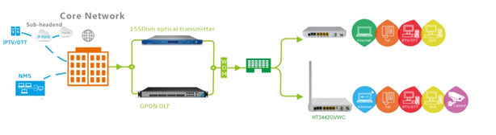

Ordering information
 | P/N | Description
4GE + 2POTS + CATV+ Wi-Fi+1 USB GPON ONU | HT3442GVWC | 4*10/100/1000M Ethernet interface, 1 GPON interface, 2 POTS interface, support Wi-Fi function, Input optical power -15dBm～0dBm, Plastic casing, external power supply adapter
 | HT3442GVWUC-B | 4*10/100/1000M Ethernet interface, 1 GPON interface, 2 POTS interface, support Wi-Fi function, Input optical power -18dBm～-9dBm, Plastic casing, external power supply adapter
 | HT3442GVWUC-C | 4*10/100/1000M Ethernet interface, 1 GPON interface, 2 POTS interface, support Wi-Fi function, Input optical power -18dBm~0dBm, Plastic casing, external power supply adapter

