What is the difference between EPON and GPON?
Broadband access technology is on the rise, destined to become a battlefield where the smoke will never dissipate. At present, ADSL technology still dominates the domestic market, but more and more equipment manufacturers and operators have set their sights on optical network access technology. This article mainly introduces the difference between GPON and EPON, specifically, follow along with the small writer to understand.
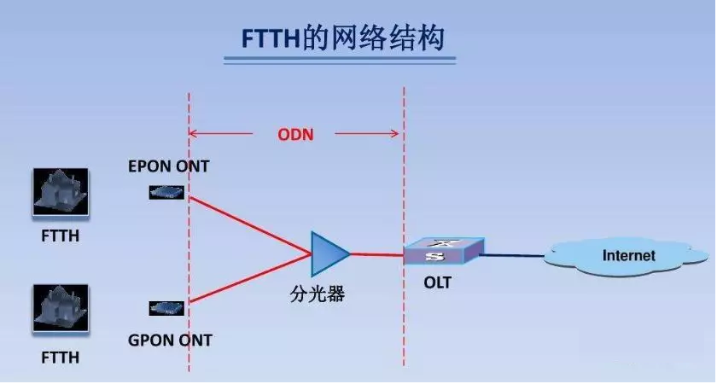
Introduction to EPON and GPON

What is EPON?
EPON is an IEEE standard, EPON uses a point-to-multipoint architecture, passive fiber transport, and provides a variety of services over Ethernet. With IP/Ethernet applications now accounting for more than 95% of all LAN communications, EPON is the most efficient way to connect end-users to access networks due to its economical and efficient architecture, and the advent of the 10Gbps Ethernet backbone and metro ring will make EPON the best last-mile solution for future all-optical networks.

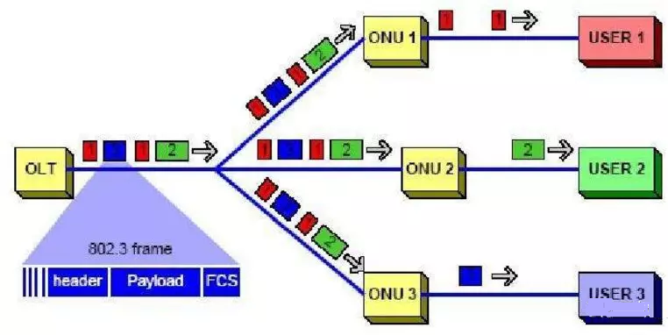
In an EPON, without any complex protocols, optical signals can be transmitted accurately to the end user, and data from the end user can be centrally transmitted to the central network. In the physical layer, EPON uses 1000BASE Ethernet PHY, while in the PON's transmission mechanism, the newly added MAC control command controls and optimizes the burst data communication and real-time TDM communication between each optical network unit (ONU) and optical line terminal (OLT), while in the second layer of the protocol, EPON uses the mature full-duplex Ethernet technology, using TDM, because the ONU sends the datagram in its own time slot, so there is no collision, no CDMA/CD, thus fully utilizing the bandwidth. In addition, EPON provides QoS similar to APON/GPON by implementing 802.1p in the MAC layer.

What is GPON?
GPON, FSAN and ITU have standardized it, and its technical features are the use of ITU-T-defined GFP (Generic Frame Generation Protocol) in the second layer to encapsulate the mapping of Ethernet, TDM, ATM and other services, can provide 1.25Gbps and 2.5Gbps downlink rates, and 155M, 622M, 1.25Gbps, 2.5Gbps several uplink rates, and has strong OAM function. Without taking into account that EPON can see a near-term increase to 10Gbps rates (10G Ethernet is mature), GPON currently has advantages in terms of high rates and support for multiple services, but the complexity and cost of the technology is currently higher than EPON.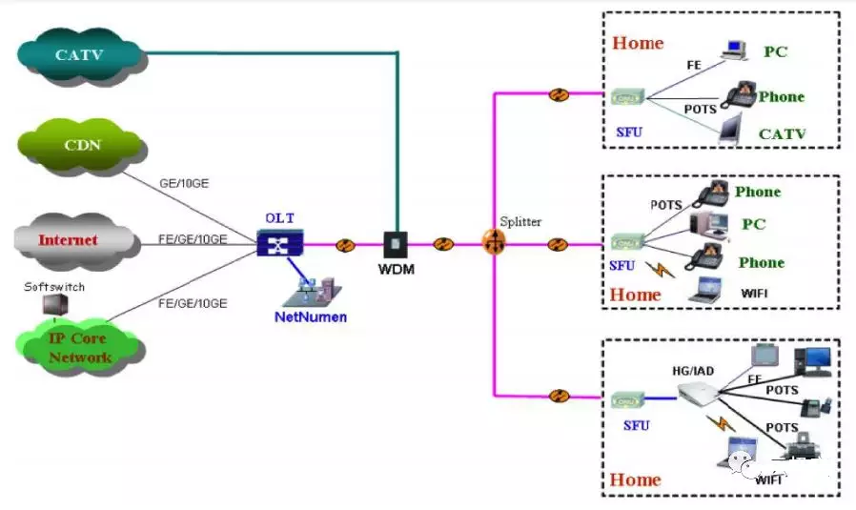
PON systems are undoubtedly the best among them, EPON and GPON, the two technologies are different, both EPON technology and GPON technology, the application is largely determined by the rapid reduction of fiber access costs and business needs, while price is the most central factor.

EPON vs. GPON
EPON is a continuation of the 802.3 protocol in optical access networks, which has the advantages of low price, flexible protocol and mature technology, with a wide market and good compatibility. GPON, on the other hand, is positioned in the telecom industry for multi-service, QoS-assured all-services access needs, and strives to find an optimal, all-service-supporting and most efficient solution, proposing "a complete and thorough rethink of all protocols openly.

The technical features of EPON are as follows.
1) Ethernet is the best carrier for IP services;
(2) Simple maintenance, easy to expand, easy to upgrade;
(3) EPON equipment is mature and available, EPON has laid millions of lines in Asia, the third generation of commercial chips have been launched, the price of related optical modules, chips have dropped significantly, reaching the level of commercial scale, can meet the requirements of the recent broadband services;
(4) EPON protocol is simple and low cost, low equipment cost, the most suitable technology is needed in the metro access network, not the best technology;
(5) More suitable for domestic, metro area network without ATM or BPON equipment baggage;
6) more suitable for the future, IP bear all services, Ethernet bear IP services.
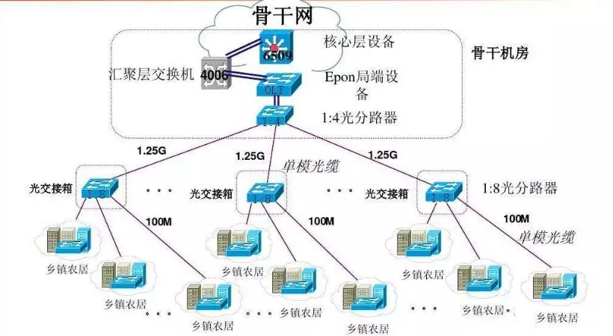

The technical features of GPON are as follows.
1) Access network for telecommunications operations;
(2) High bandwidth: line rate, 2.488Gb/s downstream, 1.244Gb/s upstream; 3) High transmission efficiency: 94% downstream (actual bandwidth of 2.4G) and 93% upstream (actual bandwidth of 1.1G);
(3) Full service support: G.984.X standard strictly defined to support carrier-grade full service (voice, data and video);
4) Strong management capabilities: rich features, sufficient OAM domain reserved in the frame structure, and OMCI standard developed;
(5) High service quality: various QoS levels can strictly guarantee the bandwidth and delay requirements of the service;
(6) low comprehensive cost: long transmission distance, high splitting ratio, effective sharing of OLT costs, reduce user access costs.

Difference between EPON and GPON
1, EPON and GPON use different standards, it can be said that GPON is more advanced, can transmit a larger bandwidth, can bring more users than EPON. GPON is derived from the early APON/BPON technology of fiber optic communication, which evolved from the ATM frame format used to transmit streams. EPON's E refers to interconnected Ethernet, so EPON was born with the need to be able to connect directly and seamlessly to the Internet, so EPON's code flow is in the frame format of Ethernet. Of course, in order to accommodate transmission over fiber, a layer of EPON-defined frame format is wrapped around the outside of the frames in Ethernet frame format.

2, EPON standard is IEEE 802.3ah, the basic principle of IEEE to develop EPON standard is to try to standardize EPON within the 802.3 architecture, the minimum expansion of the standard Ethernet MAC protocol.

3、GPON standard is ITU-TG.984 series standard, the development of GPON standard takes into account the support for traditional TDM services, continue to use 125ms fixed frame structure, in order to maintain 8K timing continuation. In order to support multiple protocols such as ATM, GPON has defined a new encapsulation structure GEM: GPONEncapsulaTIonMethod, which can encapsulate data from ATM and other protocols into frames.

4, in the application, GPON than EPON bandwidth is greater, its service bearing more efficient, more powerful spectral splitting ability, can transmit greater bandwidth services, more users access, more focus on multi-service and QoS guarantee, but the realization of more complex, which is leading to its cost relative to EPON is also higher, but with the large-scale deployment of GPON technology, GPON and EPON cost difference in the gradual reduction.

5、GPON and EPON protocol stack comparison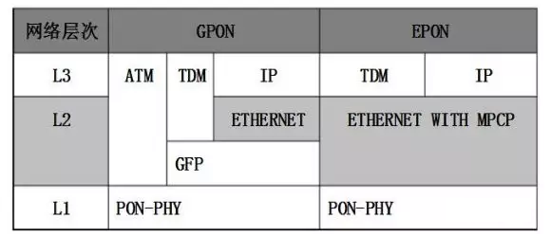

EPON and GPON have their own unique characteristics, GPON is better than EPON in terms of performance indicators, but EPON has the advantage of time and cost, GPON is catching up, looking forward to the future broadband access market may not be who replaces whom, it should be coexistence and complementarity. For customers with high bandwidth, multi-service, QoS and security requirements and ATM technology as the backbone, GPON is more suitable. For the cost-sensitive, QoS, security requirements are not high, EPON becomes the dominant customer group.

