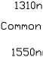

Fiber optic innovator

1x3 PON Filter WDM

Features
Wide pass band Low insertion loss
High channel isolation
High stability and reliability
Application
FTTH/PON

Specifications

Parameter | 1x3 1310/1490/1550
Central wavelength (nm) | 1310, 1490, 1550
Pass band wavelength(nm) | 1490 ± 10
Reflection wavelength(nm) | 1310 ±40 & 1550 ± 10
Insertion Loss at 1490nm (dB) | ≤0.8 (0.6 typical)
Insertion Loss at 1310nm (dB) | ≤0.5 (0.3 typical)
Insertion Loss at 1550nm (dB) | ≤1.0 (0.8 typical)
Isolation at 1490nm(dB) | ≥30
Isolation at 1310nm(dB) | ≥20
Isolation at 1550nm(dB) | ≥15
Directivity (dB) | ≥55
Return loss (dB) | ≥50
PDL(dB) | ≤0.10
Wavelength thermal stability (dB) | ≤0.003
Insertion loss thermal stability(dB) | ≤0.005
Power handling (mW) | ≤500
Operating temperature(℃) | -40 ~ +85
Storage temperature(℃) | -40 ~ +85
Dimensions(mm) | Ф5.5×L50

Package Dimensions

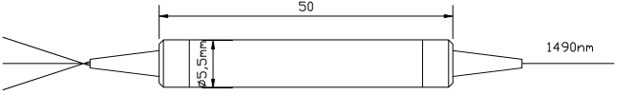

Ordering Information

FWDM | Port Type | Wavelength | Pigtail Type | Fiber Type | Length | Connector
 | 1x3 | T1490/R1310,1550 | 250=250um bare  fiber  900=900um loose  tube  3000=3mm loose  tube | 1=SMF-28e | 1= 1m X=Specify | NE=None FA=FC/APC FC=FC/UPC SA=SC/APC SC=SC/UPC LC=LC/UPC LA=LC/APC XX=Other

www.htopto.com

