Fiber Optic Innvator

1 x 2 Coarse Wavelength Division Multiplexer (CWDM)

Features
Wide pass band Low insertion loss
High channel isolation
High stability and reliability
Application
CWDM system
CWDM Mux/Demux module

Specifications

Parameter |  | Value
Central Wavelength(nm) |  | 1271, 1291, 1311, …..1551, 1571, 1591, 1611
Operating Wavelength (nm) |  | 1260~1460 or 1460~1620 or 1260~1620
Channel space (nm) |  | 20
Channel bandwidth (nm) |  | λc ± 6.5
Channel flatness (dB) |  | ≤0.4
IL (dB) | Pass Channel | ≤0.6
 | Reflection Channel | ≤0.4 (1260~1460 or 1460~1620) or  ≤0.6(1260~1620)
Isolation (dB) | Adjacent channel | ≥30
 | Non-adjacent channel | ≥40
 | Reflection Channel | ≥15
Directivity (dB) |  | ≥55
Return loss (dB) |  | ≥50
PDL (dB) |  | ≤0.15
Wavelength thermal stability (nm/℃) |  | ≤0.003
Insertion loss thermal stability (dB/℃) |  | ≤0.005
Power handling (mW) |  | ≤500
Operating temperature (℃) |  | 0 ~ +70
Storage temperature (℃) |  | -40 ~ +85
Dimensions (mm) |  | φ5.5×L34

Package Dimensions
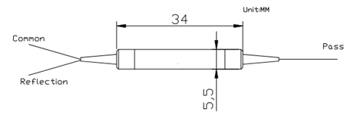

Ordering Information:

CWDM | Port Type | Wavelength | Pigtail Type | Fiber Type | Length | Connector
 | 1x2 | 1271  1291  ……  1611 | 250=250um bare fiber 900=900um loose tube 3000=3mm loose tube | 1=SMF-28e | 1= 1m X=Specify | NE=None FA=FC/APC FC=FC/UPC SA=SC/APC SC=SC/UPC LC=LC/UPC LA=LC/APC XX=Other

www.htopto.com

