12Core Fanout Pigtail Single-Mode Bunch Ribbon Fiber Optic Cable

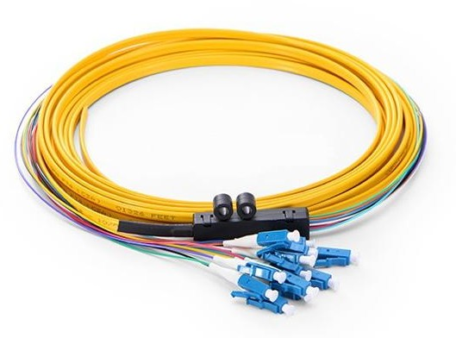

1、Description
Fiber optic pigtails provide a fast way to make communication devices in the field.
They are designed, manufactured and tested according to protocol and performance dictated by the industrial standards, which will meet your most stringent mechanical and performance specifications.

2、Features
- 100% factory tested assemblies with traceable test data,Low environmental sensitivity
- Low insertion loss High return loss Stricter than industry standards
- Good exchange ability and good durability Stable optical properties
- Standard connector Various connector option: LC、SC、FC、ST etc.
- Compliant with IEC61754，GR-326，TIA/EIA 568 standard

3、Specification

Fiber Type | SM（9/125um） |  | MM（50/125um、62.5/125um）
Polish | UPC | APC | UPC
Insertion Loss  （typical） | ≤0.30dB |  | ≤0.30dB
Return Loss | ≥50dB | ≥60dB | ≥20dB
3D | Radius of Curvature :10-25mm (PC/UPC) ，5-12mm (APC） Apex offset: 0-50um  High fiber: ±100 nm Angle：8±0.2° (APC）
Repeatability | 1000 times typical change value ≤ 0.20dB
Interchangeability | ≤0.20dB
Cable Diameter (Branch) | 0.9mm
Jacket Material(optional) | LSZH、OFNP、OFNR、PVC
Fiber Mode(optional) | G652D, G657A, G657B, OM1, OM2, OM3, OM4
Operating Temperature | -20 ~ +70 ℃
Storage Temperature | -40 ~ +85 ℃

TBF color code sequence

TBF Color | 1 | 2 | 3 | 4 | 5 | 6
 | Blue | Orange | Green | Brown | Slate | White
 | 7 | 8 | 9 | 10 | 11 | 12
 | Red | Black | Yellow | Purple | Pink | Aqua

4、Application
- CATV，LANs，WANs
- Telecommunication networks
- Active device termination
- Data center system networks
- Video and military active device termination

